|  |  |  |  |  |  |  |  |
| --- | --- | --- | --- | --- | --- | --- | --- |
| OpenreachLogo_Purple | |  | | --- | | ISIS directive  For BT People & Contractors | | EPT/ANS/A011 | | Issue 27, 25-Feb-2020  Use until 24-Feb-2022 | | Published by OR Access Engineering & Innovation | | Privacy- None | | |
| Specification for Dropwire Work | |  |
| Provision & Renewal of Dropwires within the Openreach Access Network | |  |

About this document ...

Author

The author of this document may be contacted at:

|  |
| --- |
| Wesley Grantham |
| Electrical Protection & Overhead Professional |
| Openreach (BOI) |
| Post Point BY2Grimsby Pyewipe TEC  Estate Road No. 2  South Humberside Ind Est  Grimsby  LINCS  DN31 2TJ |
|  |
| Telephone: +447736637011 |
| Fax: |
| Email: wesley.grantham@openreach.co.uk |

Content approval

|  |
| --- |
| This is the Issue 27 of this document. |
| The information contained in this document was approved on 25-Feb-2020 by Glen Barford, Overhead Network Policy and Standards Specialist |

**Version History**

|  |  |  |  |
| --- | --- | --- | --- |
| Version No. | Date | Author | Comments |
| Issue 27 | 25-Feb-2020 | Wesley Grantham | Author update and document updated to incorporate AEI/AEC/B335 DILOR rules only. |
| Issue 26 | 18-Mar-2019 | ISIS co-ordinator Network Engineer's Office | Change to 180° wire loadings info in sec 4.3.5. |
| Issue 25 | 13-Mar-2019 | ISIS co-ordinator Network Engineer's Office | Correction to references in table 4.10.4 |
| Issue 24 | 07-Sep-2018 | ISIS co-ordinator . | Changes to DILOR Rule – Section 6. |
| Issue 23 | 05-Jan-2016 | ISIS co-ordinator . | Sections 4.10.2 and 4.10.3 amended to incorporate AEC B118. |
| Issue 22 | 03-Mar-2015 | Document Manager T | Document migrated onto new platform with no content change |
| Issue 22 | 17-Dec-2013 | ISIS co-ordinator . | AEC/B132 incorporated as section 4.7 (AT 278) |
| Issue 21 | 22-Nov-2013 | ISIS co-ordinator . | 1 - DW15 replaced CAD55 as per AEC B057. 2- New sub sections 4.6.8.1 to 4.6.8.4 regards 3 span rule provided. (AT) |
| Issue 20 | 22-Aug-2012 | Chief Engineer's Office Technical Documentation team | Change of approver.Document reviewed and updated to reflect the new 3 span rule (AEC B117 refers) from Sept 1st 2012 i.e. section 4.5, 4.6.2, 4.6.3, 4.6.7,4.6.8,4.6.10 & 4.6.11. Sect 5 1) updated for AGC use at carrier pole clamps and EU fixings |
| Issue Draft 19b | 7-Aug-2012 | Chief Engineer's Office Technical Documentation team | Updated to reflect 3 span rule and AGC usage as per AEC B117 feedback and issue 1 distribution |
| Issue Draft 19a | 21-May-2012 | Chief Engineer's Office Technical Documentation team | Proposed changes by A Lupton to reflect the new 3 span rule |
| Issue 19 | 10-Apr-2012 | Chief Engineer's Office Technical Documentation team | Amendment to Bracket 51 to include 68m span. Addition of Dropwire 11 (JP) |
| Issue 18 | 2-Apr-2012 | Chief Engineer's Office Technical Documentation team | Inclusion of Dropwire 15 (JP) |
| Issue 17 | 3-Jan-2012 | Chief Engineer's Office Technical Documentation team | Addition of 4.6.4 re-tensioning dropwires on chimneys (JP) |
| Issue 16 | 17-Oct-2011 | Chief Engineer's Office Technical Documentation team | Document reviewed.Para. 4.9.3.1 revised to include Risk Assessment. (DCC1412PD) |
| Issue 15 | 13-Oct-2011 | Chief Engineer's Office Technical Documentation team | DILOR table revised at section 6.1 (JP) |
| Issue 14 | 5-Aug-2011 | Chief Engineer's Office Technical Documentation team | Document reviewed.Bracket 51 now included in fittings. (DCC1379PD) |
| Issue 13 | 2-Mar-2011 | Chief Engineer's Office Technical Documentation Team | Section 6.1 (notes / bullets) updated. DCC1225/SH. |
| Issue 12 | 10-Feb-2011 | Chief Engineer's Office Technical Documentation Team | Document reviewed.Para. 2.1, 4.1, 4.2, 4.3.5, 4.6.4, 4.7, 4.9.6, 4.9.7, 6.1, 6.1.1 revised. (DCC1206PD) |
| Issue 11 | 25-Jan-2011 | Chief Engineer's Office Technical Documentation Team | Document reviewed.Para. 4.9.3.1 revised - broken link to SFY/HSH/D030 re-instated & reference to NWK/NNS/V009 deleted.(DCC1180PD) |
| Issue 10 | 30-Dec-2010 | Chief Engineer's Office Technical Documentation Team | Document reviewed.Para. 4.4, 4.6.3, 4.6.7.1, 4.6.7.2, 4.6.9, 4.9.4 revised.Para. 4.9.3.1 added. (Incorporation of EM 8-2010)(DCC1108PD) |
| Issue 9 | 29-Oct-2010 | Chief Engineer's Office Technical Documentation Team | Sections 4.3, 4.3.4.1 updated. EM17/2010 incorporated. DCC916/SH. |
| Issue 8 | 19-Oct-2010 | Chief Engineer's Office Technical Documentation Team | Document reviewed.Para. 4.11 revised. (DCC672PD) |
| Issue 7 | 27-Apr-2010 | Chief Engineer AEI Technical Documentation Team | Update to Section 4.3.4. DCC770/SH |
| Issue 6 | 22-Mar-2010 | Chief Engineer AEI Technical Documentation Team | Sections 4.4 & 4.12 Updated. (DCC687 & 701/SH Refer) |
| Issue 5 | 26-Feb-2010 | Chief Engineer AEI Technical Documentation Team | Change to Section 4.1 (DCC688/SH refers) |
| Issue 4 | 25-Feb-2010 | Chief Engineer AEI Technical Documentation Team | Updated and change of Approver. (DCC668/SH) |
| Issue 3 | 16-Feb-2010 | Chief Engineer AEI Technical Documentation Team | Updated / Change of Approver. (DCC623/SH) |
| Issue 2 | 27-Apr-2009 | Chief Engineer AEI Technical Documentation Team | New section 4.2 Envelopes of available space. Also change of Author & Approver |
| Issue 1 | 21-Feb-2007 | Dave Parcell-Jones | New document |

Table of Content

1 Introduction 5

2 Glossary 5

2.1 Products 5

2.2 Terms 9

3 General Description of the Work 10

4 Requirements 10

4.1 General Performance Requirements 10

4.2 Envelopes of Available Space for Pole Mounted Equipment / Connector Systems etc. 11

4.3 Dropwire Loadings on Poles 14

4.4 Current Standard Wires 17

4.5 Current Approved Joints 17

4.6 Wire Replacement Requirements 18

4.7 Fixing dropwires to poles with no ring head or to other positions on the pole 24

4.8 Dropwire Management 27

4.9 End User Lead-in (Provision & Repair) 28

4.10 Current Standard Dropwire Fixings and Requirements 29

4.11 Current Standard Dropwire Clamps 39

4.12 Wire Clearances 40

4.13 Span Length Limits 40

4.14 Tree Pruning and Lopping 41

5 Appendix 1 - Above Ground Closure 41

6 Appendix 2 - Dropwires in Line of Route (DILOR) 43

6.1 Dropwires in line of route 43

6.2 Un-Stayed Poles / Poles with no opposing wire load 44

6.3 Stayed Poles, or poles with an opposing wire load 47

6.4 Options to mitigate DILOR problems 49

6.5 DILOR Q&A: 50

# Introduction

This Document forms part of the Access Network Specification range of ISIS Documents and is applicable to both Openreach Direct Labour and Contractors.

The information below details the performance requirements for the Provision, Replacement and Recovery of Overhead Wires within the Openreach Network. Practices and items of plant are only detailed where necessary to ensure that Openreach Network & Plant are not compromised.

1. The Specifications for Poles & Stays are covered in other Documents in the range. See EPT/ANS/A001 for an index of all Access Network Specifications.

# Glossary

## Products

|  |  |
| --- | --- |
| Item | Description |
| Above Ground Dropwire Closure | (Item Code 026014) Guidance. A gel filled plastic closure approximately 140mm long. Replaces Box Connection 16A and Block Terminal 66B for housing joints in dropwire at Premises. |
| Bolt 25 | (Item Code 010511) A 100 x 16mm galvanised steel bolt with 2 washer & nyloc retaining nut. Used to attach Hook Clamp Dropwire to Pole Ring Head 15 Way. |
| Bolt Expanding 2A | (Item Code 021689) A 16mm x 90mm expanding bolt with a 30mm dia washer. Used for attaching Plate Wall 5A and Bracket 44 to Rendered / Pebble dashed walling. Requires a 16 mm hole to be drilled into walling. |
| Box Connection 16A | OBSOLESCENT; A square plastic box with a hinged lid measuring approximately 64 x 64 x 23 mm. Was available in black, brown, cream, grey or white and used at end user premises when a joint in the dropwire was necessary. |
| Box Connection 18A | (Item Code 051894) A plastic box with a slide on lid measuring approximately 350 x 190 x 56 mm. Available in black. External distribution box for mounting on Poles or Walls. Allows up to 20 External Connection Modules 1A to be fitted, and up to 2 x 20 pair cables. Earth connection can be made when required by fitting an upgrade kit (Item Code 051899) i.e. for Lightning Protection. |
| Box Connection 19A | (Item Code 051897) A plastic box with a slide on lid measuring approximately 210 x 170 x 84 mm. Available in black. A vented enclosure capable of accepting up to 10 modules, 2 incoming cables, an earth wire connection and 10 dropwires. Earth connection can be made when required by fitting an upgrade kit (Item Code 051926) i.e. for Lightning Protection. The box is fitted with enhanced security features which can be utilised if required. |
| Block Terminal 66B | (Item Code 072256) A rectangular plastic box with a slide on lid measuring approximately 115 x 90 30mm. Available in grey only. Used on a Pole or a building when it necessary to make a joint in the dropwire. |
| Block Terminal 71A | (Item Code 072125) A Plastic box with a slide on lid measuring approximately 475 x 75 x 35 mm. External block terminal for accommodating up to 20 dropwires. It is used within Hollow Poles as an interface to connect Dropwires to the Underground Cable Feed. The dropwire is connected to the cable by means of Connector Dropwire or Connector Wire Insulated series connectors and all types of dropwire can be accommodated. |
| Bracket 22 | (Item Code 011114) A dropwire fixing consisting of a galvanised steel triangular Bracket with three fixing holes and a welded loop. Designed to attach a dropwire clamp to timber at end users premises or on a multi pole route where no pole ring exists. |
| Bracket 32 | (Item Code 016264) A dropwire fixing consisting of a galvanised steel “J” shaped Bracket with a welded loop and a plate with four holes at the other end. Designed to attach a dropwire clamp to timber or brickwork at end users premises where additional height clearance is required e.g. a Bungalow. Note: Dropwire span limit for this Bracket is 40 metres.  On timber this Bracket is designed to be secured with 4 No 12 x 1 Zinc plated screws. On brickwork (without rendering or cladding) this Bracket is designed to be secured with 2 x Stud Expanding 1A and 2 No 12 x 1½” Zinc plated CSK screws and Plugs Screw Fixing 1A. |
| Bracket 44 | (Item Code 009561) A dropwire fixing consisting of a galvanised steel “L” shaped Bracket with a welded loop at one end and a plate with two holes at the other end. Designed to attach a dropwire clamp to brickwork at end users premises where further additional height clearances is required. Maximum span length is 68 metres. On brickwork (without rendering or cladding) this Bracket is designed to be secured with 2 x Bolt Expanding 2A |
| Bracket 51 | The Bracket 51 is attached to the wall by the same drilling method as the Bracket 44 but, as this bracket stands out further from the wall and is considerably taller; **fitting from a MEWP (Mobile Elevating Work Platform) should be the first consideration.** Maximum span length is 68 metres. On brickwork (without rendering or cladding) this Bracket is designed to be secured with 2 x Bolt Expanding 2A |
| Cable Downlead 1 | (Item Code - Various) A two pair polyethylene sheathed cable with an over sheath. Available in brown, cream, grey or white. Used when the end user requires different coloured cable to extend the dropwire into the premises. |
| Clamps Dropwire 6A | (Item Code 016309) A coated metallic spiral clamp approximately 220 mm long. Used to attach either a dropwire 10 or 12 inside a Hollow Pole. Designed to be wrapped around the dropwire, not the wire around the clamp. |
| Clamp Dropwire 10A | (Item Code 016443) A coated metallic spiral clamp approximately 430 mm long. Used to attach either a Dropwire 10B or 12 to a Pole ring or any dropwire fixing. The clamp is designed to be wrapped around the dropwire, not the wire around the clamp. |
| Cleats Wiring 11B | (Item Code – Various) Plastic wiring cleats with steel pins for use with dropwires or downleads. Available in black, brown, cream, grey or white. Used to secure dropwire or downlead to either masonry (with Pin Plug 1A) or timber structures. |
| Dropwire 3 | OBSOLETE: One pair of 0.71 mm diameter Copper coated steel wires, PVC insulated, approximately 3 mm wide with a figure of 8 constructions. |
| Dropwire 6 | OBSOLETE: One pair of 0.81 mm diameter Copper coated steel wires; PVC insulated, figure of eight construction, approximately 5 mm wide. |
| Dropwire 8 | OBSOLETE: One pair of 1.14 mm diameter Cadmium / Copper wires, PVC insulated. |
| Dropwire 10 | OBSOLESCENT: A two pair dropwire with 0.5 copper conductors and separate steel strength members enclosed in a black polyethylene sheath. |
| Dropwire 10B | (Item Code 055201) The cable make up is similar to Dropwire10 except that the conductor insulation is made of Polyethylene and has an additional tape over core. Used either when an end user requires a single line or two lines terminated on the same NTE. The change of Conductor insulation material from PVC to Polyethylene allows 10B to be used when crossing below HV Power Lines (not exceeding 11kV) High Voltage breakdown performance similar to Dropwire12, thus removing the need to change dropwires when crossing below HV Power crossings (not exceeding 11kV). |
| Dropwire 11 | (Item code 066105) A single pair 0.5mm conductor Dropwire suitable for spans up to 68 metres (inc road crossings). Supersedes DW10B which will no longer be available when existing stocks are exhausted.  DW11 has the same diameter and is compatible with standard copper drop wire accessory fittings. NB: Stripper Cable Sheath 7 (126853) is the correct tool for stripping dropwire 11! |
| Dropwire 12 | (Item Code 055704) A single pair dropwire with 0.9 mm copper conductors and separate steel strength members enclosed in a black polyethylene sheath. Commonly used where known transmission problems (requiring a larger conductor size) exist. Designed for use under Power crossings up to 11kV. |
| Cable Aerial Dropwire 55M (CAD 55M) | OBSOLESCENT: Item Code 002719. A four pair 0.5 mm construction. Max Span length = 55 metres for road crossing and 68 metres for non-road crossings. NB: This item has been superseded by Dropwire 15. |
| Cable Dropwire 15 | (Item Code 062778). Cable Dropwire 15 is a 4 pair, 0.5mm conductor Dropwire which can be used for spans up to and including 68m including road crossings.  Dropwire 15 has the same diameter as other standard Dropwires and is compatible with their fittings (i.e. DW Clamp). It can be used as an alternative to Aerial Cable for situations as noted in section 4.4. |
| Eyebolt Expanding 1A | (Item Code 016445) A dropwire fixing consisting of a Zinc plated steel eyebolt with an M6 thread. This is the preferred method of attaching a dropwire to brickwork at end users premises. |
| Eyebolt Expanding 2A | (Item Code 016442) A dropwire fixing consisting of a Zinc plated steel eyebolt with an M10 thread. This is the preferred method of attaching a dropwire to the end users premises, where the walls are rendered. |
| Eyebolt Expanding 2B | (Item Code 023041) A dropwire fixing consisting of a Zinc plated steel eyebolt with an M10 thread. This is suitable for fitting to brick or concrete construction walls where the thickness of the insulation / rendering / pebble dashing of the wall can be between 70 and 90 mm thick. The eye of the bolt is bigger than the Eyebolt Expanding 2A for easy recognition. This eyebolt is for use on properties which have been clad with external wall insulation (EWI) and surface rendering on the outside walls. |
| Eyebolt Expanding 2C | (Item code 076275) Very similar to the Eyebolt 2B, the 2C is suitable for use where the insulation / rendering are up to 100mm thick. |
| Hook Clamp Dropwire | (Item Code012221) A dropwire fixing consisting of a Zinc plated steel double loop formed from a 4.75 mm steel bar. Used to attach a dropwire clamp to Pole Ring head 15 way. |
| Pin Plug 1A | (Item Code 545509) A plastic “bullet” shaped plug having an overall length of approximately 18 mm. Used with Cleats Wiring 11B when securing a dropwire or downlead to brickwork. Designed for use in a 5 mm diameter hole. |
| Plug Screw Fixing 2A | (Item Code 070883) A plastic “bullet” shaped plug having an overall length of approximately 35 mm. Used for holding a screw in masonry. Designed for use with an 8mm diameter hole. |
| Ring Pole Head Stand Off 1A | (Item Code 016286) A bolt on galvanised steel pole step with a welded 100 mm diameter ring. Used to attach a maximum of five dropwires on Joint user poles when a Stand-off 1A dropwire needs to be terminated. The stand-off enables DNO staff to safely climb past BT / Openreach plant. |
| Ring Pole Head Dropwire | (Item Code 021240) Two galvanised split rings 12 mm thick, with a radius of 120 mm and 2 eye formed ends. The two rings are held together with a galvanised bolt.  Current item. This was designed to accommodate a maximum of 30 wires. Prior to its introduction in 1957 there were other types of rings used which are also still present in the Network. |
| Ring Pole Head Ring Type Split 15Way | OBSOLESCENT. A cast alloy ring or galvanised channel, formed into a ring and having 15 sets of holes around the circumference. Originally used to attach open wires to a Pole using insulators. |
| Sealant Silicone Clear | (Item Code 127865) Clear liquid silicone sealant. Requires an application gun. Used to seal around the hole where the dropwire enters end users premises. |
| Stud Expanding 1A | (Item Code 016303) Zinc plated steel stud with an M6 thread (similar to Eyebolt Expanding 1A). Used when securing a Bracket 32 to brickwork. Designed for use in an 8mm diameter hole. |
| Universal Pole Bracket (UPB) | (Item Code 016988) The UPB is made from a high strength corrosion resistant aluminium alloy. Its dimensions are 120mm x 114mm x 46 mm. It has two upper apertures, each suitable for three dropwires. Two central apertures each suitable for either, one Aerial Cable or dropwire One lower aperture suitable for either dropwires, Aerial Cable or stay wires.  Two recesses are provided on the bracket to facilitate use of stainless steel banding to attach the bracket to a wood or steel telephone pole.  NOTE: For further information on the UPB please refer to ISIS EPT/ANS/A012. |

## Terms

|  |  |
| --- | --- |
| AAPO | Asset Assurance Programme Office |
| BT | Block Terminal |
| BC | Box Connection |
| DNO | Refers to the Power Distribution Network Operator. (Formally Regional Electricity Company). |
| End User | The Customer of the Communications Provider i.e. Bulldog, Talk Talk or BT Retail. |
| Lopping | The removal of large branches from a Tree. |
| NTE | Network Terminating Equipment. |
| NTP | Network Termination Point. |
| Obsolete | Within this Document, the term OBSOLETE refers to Products / Practices which have been withdrawn and which are no longer authorized for use in the Network. |
| Obsolescent | Within this Document, the term OBSOLESCENT refers to Products / Practices which although Outdated / Superseded, are currently still authorized for use in the Network. |
| Pruning | The removal of small size growth from a tree. |
| SA | Specification Authority (Openreach Network Capability & Development). |
| Tree | To be taken to mean Trees, Shrubs, Bushes, Hedgerows etc. |
| Wayleave (Tree) | Prior permission in writing, from the owner of the Tree for the work to be carried out. |
| Works Executioner | The Person / Organisation undertaking the work. |

# General Description of the Work

The Provision, Renewal and Recovery of Overhead Dropwires within the Openreach Overhead network.

# Requirements

## General Performance Requirements

The work executioner shall comply with the following performance requirements:

1. Only SA approved items shall be used when providing overhead dropwires.

2. Clamp Dropwire 6A and 10A shall only be used once and NEVER Re-used. There shall be no damage to sheath, strength members or any of the copper pairs contained within the dropwire.

3. Dropwires in line of route – see Appendix 2.

4. When providing the End User lead-in:

* There shall be no damage to the End User’s premises.
* Positioning of the lead-in shall be agreed with the End User
* When a continuous length of dropwire is terminated inside the End User's premises a loop of dropwire 150 - 200 mm in diameter shall be provided near the End User’s fixing for future use.
* No End User lead-in shall be within 100 mm of any double glazed unit unless the unit is specifically designed to allow the entry of the lead-in.
* The recommended clearance hole for the lead-in is 6 mm diameter.

5. No fittings shall be attached to chimney stacks which extend above the roof line/level. Fixings can be made to chimney stacks (below roof line level) built on external walls providing the eyebolt is positioned in the centre of the selected brick and there is at least one brick either side and at least two bricks above/below which are keyed into the wall of the building.

Existing dropwires fixed to a chimney stack shall not be re-tensioned or otherwise left in place, including after a pole change out but should be renewed and re-attached to an approved fixing point using an eyebolt or bracket 22, 32, 44 or 51

When Dropwires are recovered, all clamps, Brackets and wire shall also be recovered unless instructed otherwise by the end user.

6. No fittings shall be attached to trees, lamp posts or any other structure not authorised within this document. Any existing Drop Wire attached to such structures and needing renewal must be re-routed off the structure and on to a carrier pole if necessary.

7. All dropwires or downleads shall be secured using Cleats Wiring 11B of the appropriate colour. The cleats shall be spaced at 300 mm intervals on horizontal sections and at 450 mm intervals on vertical sections.

When a Ring Pole Head Stand Off 1A is provided:

* The stand-off shall be fitted in line with the power conductors unless otherwise specified by electricity authority.
* A maximum of two stand offs shall be fitted to any joint use pole.
* A maximum of five dropwires shall be fitted to the ring.

1. When using Pole Head Ring Type Split 15 Way, Bolt 25 and Hook Clamp Dropwire, only 1 dropwire shall be fitted to a Hook Clamp Dropwire. A maximum of 2 Hook Clamp Dropwires may be fitted to the ring, one above the ring and one below. The Bolt 25 must be the 100mm long version.
2. The drop wire should follow a free path to avoid chaffing and damage, it should not come into contact with structures such as buildings and lamp posts. Running dropwires through trees should be avoided; if this is not possible, pruning of the branches should be considered.

## Envelopes of Available Space for Pole Mounted Equipment / Connector Systems etc.

When overhead distribution necessitates the use of cable joints, or transmission equipment the preferred option is to locate them in an underground jointing chamber.

However, where no practical or economic underground option exists the hardware may be installed on wooden poles providing that due regard is paid to the requirements of normal overhead practices and this document.

All pole mounted hardware shall comply with the following:

(a) Nothing shall be fixed to the top face of the pole, unless detailed in, or approved by the author of this document. There is now no requirement from Local Authority byelaws requiring the fitting of finials. However, retrospective action to remove such attachments need not generally be taken.

(b) There are two areas, as listed below in d and f, where hardware may be fitted. However, due regard must be paid to positioning of the hardware in order to:

(i) Avoid restricting access for fitting dropwires

(ii) Not obstruct climbing

(iii) Not obstruct safe ladder placement

(iv) Not present a hazard by way of sharp edges or corners

(v) Be readily removed for pole testing operations.

(c) All hardware shall be securely mounted to the pole but must also meet the requirement of (b) (v) regarding removal.

(d) No wiring etc. shall be fitted such as to cause obstruction to belting up below the top bass step. An exception to this is Aerial Cable which, according to circumstance, may be fitted below the bass steps. However, care should be taken to ensure that any obstruction is kept to a minimum.

(e) Access to the working and bass steps must not be impeded by any item fitted between the top bass step and the pole top.

(f) The following space may also be used for mounting hardware.

The space on either side of the pole in line with steps, extending 250mm radially from the pole, from 2.0m above ground level to immediately below the lowest climbing step. The overriding requirement is that safe ladder placement and climbing must not be obstructed (see Figure 1).

1. Joints must not be placed at the safe ladder position.

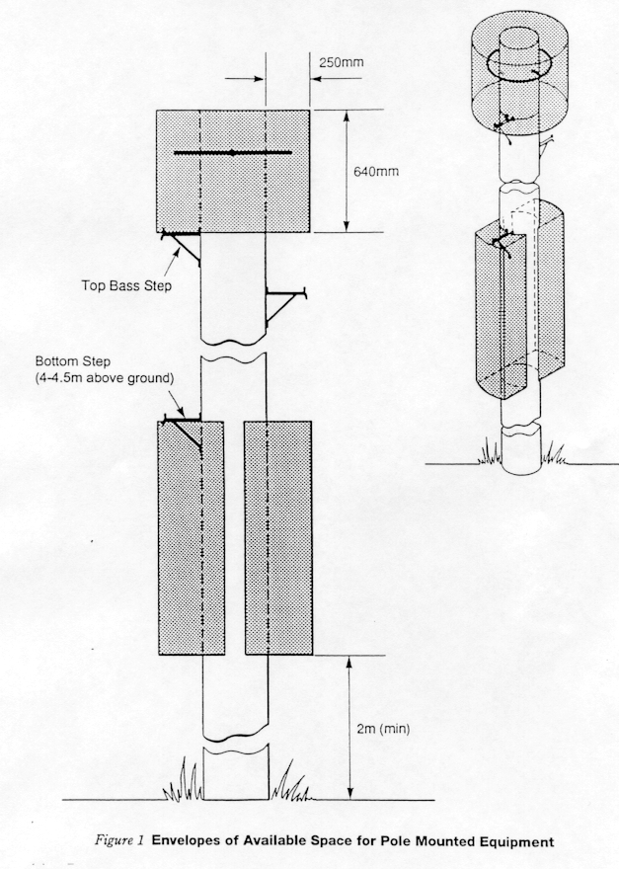

Figure 1: Envelopes of space for pole mounted equipment

(g) Due consideration should be given to the likelihood of vandalism when contemplating the use of the space described in (f). Also the visual aesthetics of hardware mounted in this position may more readily be considered visual pollution, in some locations.

## Dropwire Loadings on Poles

Wherever possible, Poles should be positioned so that dropwires to customer's premises are radially fed.

The maximum loading for poles is dependent upon the location. For Radially fed Poles, Refer to Table 1 below and the appropriate guidance to determine which category should apply.

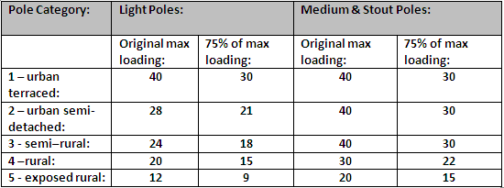

Table 1: Pole categories and loadings.

### Adding wires to ‘D’ (Defective) Poles

Further guidance for working with D poles can be found in EPT/OHP/C031.

New dropwires may be added to ‘D’ poles, provided that any wires added meet the criteria below:

* The pole does not have an unbalanced load
* The pole is not classified as PIDOC (Pole in Imminent Danger of Collapse)
* The pole is not classified as a ‘D’ due to internal or external decay (see A75)
* When additional wires are added, they do not exceed 75% of the maximum load of the pole. Table 1 above gives the figures. It is necessary to determine which category the pole falls into.

### Assessing the Pole

It is necessary to determine which of the above categories apply for any particular pole. The following questions should be answered in order to determine the category.

### Determining Pole Category

Start with Question 1, and then follow the instructions until a category is determined.

|  |  |  |
| --- | --- | --- |
|  |  |  |
| Q1 | Is the pole in an urban\* setting? | Yes - go to Q2 No - go to Q6 |
| Q2 | Is it a road or street with houses or similar buildings on both sides? | Yes - go to Q3 No - go to Q5 |
| Q3 | Are the houses terraced, or if other buildings, are they close together, with little or no gap between? E.g. For terraced houses it is likely there will be between 4-8 houses in a space of 40m. | Yes - Category 1 applies No - go to Q 4 |
| Q4 | Are the houses or other buildings semi-detached or detached, with gaps between, but fairly continuous along the road? E.g. it is likely that there are between 3-5 houses in a space of 40m. Industrial or other buildings could be of variable size, but the key point is, are they generally continuous? | Yes - Category 2 applies No - Either Category 1 (Q3) or Category 2 should apply |
| Q5 | If there are only houses or buildings on one side of the road, is the open side exposed right out to open countryside, with no other buildings, into the prevailing wind and weather? | Yes - Category 3 applies No Category 2 applies |
| Q6 | Is the pole in a very exposed setting? i.e. high ground, open moorland, national park etc. | Yes - Cat 5 applies No - go to Q7 |
| Q7 | Is the pole in a village/hamlet or small town setting? | Yes - go to Q8 No - go to Q9 |
| Q8 | Are the houses or buildings reasonably close together, similar to Q4 above? | Yes - Category 3 applies No - go to Q9 |
| Q9 | Is it a pole serving a farm or other similar well-spaced building(s) in a rural situation? | Yes - Category 4 applies No - Either Category 3 (Q8) or Category 4 should apply |

Table 2

\*Definition of urban:

Part of a Town, City, or other large conurbation, with a reasonable density of population. Any reasonably sized town or city in a generally low lying or unexposed area of the UK.

### Carrying out the Pole Loading Assessment

The assessment process can be undertaken by either the Works Executioner or the Works Originator prior to work being undertaken

* The questionnaire must be fully completed to correctly determine the DP category.
* If it is determined that a DP is full, then an A1024 should be raised for remedial network relief. In cases of disagreement between the planner and the A1024 originator, these need to be resolved locally.

#### Changing the Loading of a ‘D’ Pole

Further guidance for working with D poles can be found in EPT/OHP/C031.

Removing, repositioning, retensioning, or even adding a dropwire does NOT constitute a “considerable change to the pole loading”.

Examples of where work would constitute “considerable change” are:

* Removing all or most dropwires from one side of the pole, leaving an unbalanced load
* Adding new dropwires beyond the limits of Table 1 (Section 4.3)
* Permanent removal of an aerial cable
* Permanent removal of a stay
* Adding new aerial cables

### Poles with Non-Radial Loads

Where feeds are solely concentrated on one side of a pole the following limitations will apply:

* On light poles, no more than 7 dropwires should feed from a pole within a 180 degree arc and no more than 4 within a 30 degree arc.
* On medium poles, no more than 15 dropwires should feed from a pole within a 180 degree arc and no more than 5 within a 30 degree arc.
* On stout poles, no more than 30 dropwires should feed from a pole within a 180 degree arc and no more than 10 within a 30 degree arc.
* Dropwires of similar spans and of nominally 180 degree spacing may be excluded from the above limitations i.e. dropwires that balance one another need not be considered in the above conditions. (From ISIS EPT/OHP/B011).
* These loadings apply where the total loading lies within either the 180 degree or 30 degree arc, not both.
* NB: The maximum number of Dropwires (assuming only wires are attached) shall be 3 per port (15 per UPB)

## Current Standard Wires

The dropwires currently available, for new and replacement work designed to serve only one End User (unless safety exceptions apply) are:

* Dropwire 10B. 2 pair Dropwire. Always use orange white as first pair option. Superseded by Dropwire 12, this will become obsolescent when existing stocks are exhausted, but will still be considered to be of a current standard
* Dropwire 11. Single pair with 0.5mm conductors
* Dropwire 12. Single pair with 0.9mm conductors.
* Dropwire 14 (CAD55M). 4 pair Dropwire which is obsolescent, but still of a current standard)
* Dropwire 15 (4 pair with 0.5mm conductors. Replacement for CAD55)

Cable Dropwiring 15 is available for use as an alternative to Aerial Cable in the following situations:

* Where there are multiple dropwires in line of route.
* In a multi-line tenancy situation.
* For small businesses.
* Where the requirement for an aerial cable diminishes along the route (tenancy numbers taper down e.g. 8 tenancy numbers reducing down to 2 along the route).

1. Cable Drop Wiring No.15 can be used for spans up to and including 68 Metres, and road crossings

See Products Glossary for further details of the above products.

## Current Approved Joints

When it is necessary to joint a dropwire, it should be made using the correct connectors

### End user

Must be housed in an Above Ground Closure (see appendix 1 for information) or a BT66, which must be correctly attached to the wall/fascia at the End Users premises fixing position

### Carrier Pole

Must be housed in an above ground closure correctly attached to the dropwire clamp in a horizontal position with 2 x SCF1. The dropwires must be restrained to the pole with SCF 12A pinned to the pole.

Alternatively a BT66B can be used e.g. if a drop off is needed at the pole.

\*All BT 66As must be either upgraded to BT 66B standards (IDC connectors must be fitted) or replaced with an Above Ground Closure. For further information on BT66, see EPT/ANS/A006.

## Wire Replacement Requirements

### Faulty Wires

A Dropwire shall always be replaced whenever a fault (on either pair) has been proved into it. Repair or swapping End Users line to green/black (if Dropwire 10/10B) is not an option.

### Dropwire Inspection

* When working on an End Users circuit, either on the dropwire, or on an external block terminal, or on any external DACS / WB900 equipment, the Works Executioner must carry out a visual inspection of that End Users dropwire, lead in and any associated block terminals (from ground level) up to a maximum of 3 overhead spans.
* For Provision, wires in situ, the check should be carried out on the 3 spans and lead in nearest the End Users premises.
* The four minimum points to check on a visual inspection are:
* Dropwire is defect free and no obsolete dropwire exists.
* Dropwire height is correct.
* No un-approved joints.
* Covers/lids fitted correctly.

1. If any faults or defects are observed then they must be brought up to the minimum quality standard as defined by this ISIS (e.g. 3 span rule for Dropwire & exceptional circumstances for all other dropwire types).

### Re-tensioned Dropwire Inspection

Where a Dropwire is NOT being replaced / provided and is only being re-tensioned / re-erected as part of a pole replacement or low wire remedy, the work executioner is responsible for the workmanship on the single span (including lead in if working on the span to fixing) being re-tensioned / re-erected from the work point to the fixing or pole.

The five minimum points to check on a retention visual inspection are:

1. Dropwire is defect free and no obsolete dropwire exists.
2. Dropwire height is correct.
3. No un-approved joints.
4. Covers/lids fitted correctly.
5. Dropwire fixing is not faulty or defective.
6. Only current standard Dropwire Types may be Re-Tensioned.
7. If any faults or defects are observed then they must be brought up to the minimum quality standard as defined by this ISIS (e.g. 3 span rule for Dropwire & exceptional circumstances for all other dropwire types).
8. If the span from pole to customer fix is an un-damaged/defect free Dropwire and a BT66/Above Ground Closure or BC16 (that was not entered) exists at the fix and the lead in is Dropwire or an approved external wire that is defect free, then the span can be re-terminated at the pole - there is no requirement to replace the lead in unless it is obsolete dropwire.   
   Where the span is replaced due to insufficient length or is defective then all obsolete dropwire within the 3 span rule will be replaced.
9. Where the Re-tension / Re-fix are being undertaken as part of the AAPO Low Wire or D Pole Programme, the solution must clear all low wire defects on the Pole.

### Re-tensioning Dropwires attached to Chimneys

Existing dropwires fixed to a chimney stack shall not be re-tensioned or otherwise left in place, including after a pole change out, but should be renewed and re-attached to an approved fixing point using an eyebolt or bracket 22, 32, 44 or 51

### Block & Tail Renewals

Where a Block and Tail only is being renewed as part of an uplift/asset assurance remedy, the requirement is to ensure that dropwires, up to and including the pole ring head/dropwire clamps are defect free. If any dropwire is too short to go direct into the new BT, then the dropwire must be replaced.

DAC’s Unit Recovery

When a DAC’s unit is being recovered, the existing dropwires must be taken direct into the feed BT, providing an extra BT to extend the dropwire is not permitted. If the dropwire is too short to be taken directly into the feed BT, a dropwire renewal will be required.

### Definition of Faulty or Defective Dropwire

A Faulty dropwire is one which:

* Exhibits electrical fault conditions.
* Exhibits a noisy fault condition.

A Defective dropwire is one which has:

* Damaged insulation.
* Joints at the DP.
* Unapproved Joints on intermediate Poles or Lead-in.
* Signs of corrosion in length.
* Any existing open joints not housed in an approved closure.

### Joints in Dropwires

Dropwires are normally provided and renewed in continuous lengths but approved joints may be provided at the End Users premises or an intermediate pole.

### Dropwire - 3 Span Rule

To meet the Quality Standard:

* No obsolete dropwire is allowed in a 3 span section of overhead dropwire or lead in.
* Obsolete dropwire must be renewed for up to 3 spans (plus lead in at customer’s premises)
* When working on an EU lead in, including reterminations and provision in situ activities, the 3 spans & lead in at the EU premises must be checked for any obsolete dropwire.
* When renewing or working on poles over 3 spans, including reterminations, the route must be examined (from ground level) for three spans either side of the faulty span, or pole retermination, to decide which spans would replace the greatest amount of obsolete dropwire within the 3 span limit.
* Only 1 dropwire joint, at the EU fixing position, is allowed on an EU premises unless exceptional circumstances apply
* All drop wire joints on poles must use AGC attached to the DW clamp or BT66B e.g. if a drop off is needed at the pole).
* All drop wire joints on EU premises must use AGC or BT66B

#### Additional Guidance on 3 span rule for Provision & Repair activities

* The 3 span rule applies to traditional Overhead repair and provision activities e.g. when the end user has reported a fault or service needs to be provided.
* On Repair it applies to any faults cleared that involved working on the Openreach overhead network, e.g. line 7 or line 60 with an overhead dropwire or lead in. It does not include an 82.7 pair change fault
* On Provision it applies to any new Overhead provide including provision in situ e.g. completion codes 11-13 and 21 - 23.

#### Exceptions to 3 span rule for CP requested tasks

The following activities are CP requested tasks, where Openreach has tested the line and confirmed it as working OK but the CP has requested an engineering visit, or the EU has requested a managed install on a working line.

* Broadband Boost
* Managed Install
* SF12
* CDTA

The 3 span rule, including the mandatory renewal of any obsolete dropwire or lead in won’t apply to these activities unless:

* The overhead network was found to be defective
* Enhancements were carried out on it to improve service
* Network uplift needed
* To meet requirements e.g. converting ‘star wiring’ to monopoly wiring

#### No EU access

If there is no access to the EU premises then any obsolete dropwire spans should be renewed up to the AGC / BT 66B at the EU fixing position and there is no need to arrange a subsequent visit.

#### No Pole Access

If the pole is a D pole, the pole cannot be climbed or wire cannot be renewed due a low dropwire situation then renew any obsolete dropwire spans as far as possible and there is no need to arrange a subsequent visit.

### End Users fed by Wall Mounted Distribution Points

Where a defect free Dropwire or cable downlead exists between a wall mounted Distribution Point (block terminal) and the end users NTE, a maximum of one approved joint may be provided.

1. The above only refers to end users cables fed directly from wall mounted DP’s, cables fed from any other types of block terminals on the End Users premises are excluded, these should be fed by one continuous cable from the external BT to the NTE as per the Quality Standard requirements.

### All Dropwire – Exceptional Circumstances

Approved joints may be provided in modern and obsolete dropwire, where it is necessary, in the following situations:

#### Hazards

Involving crossing one of the following:

* Over a Railway
* Over Power Lines
* Over a Double Decker Bus route
* Over an “A” class road
* Over a Dual Carriageway

1. It is only necessary to renew faulty section up to the hazard if dropwire after the hazard is defect/fault free. (Provision & Repair only, not applicable to AAPO Low Wire or D Pole Renewal work)

#### Safety

Where renewing the dropwire in a continuous length would involve:

* Working on a D pole.
* Working on a Low Dropwire that cannot be raised.
* An Asset Assurance pole renewal or UG / OH Planning complex solution.

1. A dropwire can only be blocked at an end users fixing or lead in, to provide or maintain service to different end users, in those situations that would require an AAPO pole renewal or UG / OH planning solution.

#### End User access

When it cannot be completed in order to meet the end user requirements

* End Users job cannot otherwise be completed due to no access.
* End User refuses permission to carry out work.

### Joints in Dropwire

Although providing a dropwire in a continuous length is the preferred option there is no maximum limit on the number of approved joints in dropwire spans.

However, only 1 approved joint is allowed on end user premises

#### Use of the second pair in Dropwire 10

When an end user requires an AA pole renewal or non-standard solution to maintain / provide services then the second pair in another End Users dropwire can be used i.e.

* Existing DW10 to property Number 1 must be defect free
* A Wayleave must be obtained
* Second pair of DW10 must be connected using an AGC / BT66 at property Number 1
* Provide a new lead-in to property Number 2
* Submit the relevant category A1024 for any low wires that cannot be raised

Where a DW has gone faulty but cannot be replaced follow the PATD process found in ISIS NWK/NNS/V045

1. The second pair can only be used where an AA pole renewal / non-standard solution situation exists.
2. The second pair must not be used as a permanent repair if the first pair is faulty (unless using the PATD process)
3. If a wayleave cannot be agreed, another solution must be found.
4. It is only necessary to renew faulty section up to the safety item if dropwire after is defect/fault free. (Provision & Repair only, not applicable to AAPO Low Wire or D Pole Renewal work.)

#### Dropwire in Line of Route (DILOR)

Where a Dropwire 15 has been used:

* As an Asset Assurance Low wire solution
* As an alternative to aerial cable for multiple dropwires in line of route
* To provide pairs when the aerial cable requirements diminish along the route
* To connect service to end users along the route with multiple drop offs within the 3 span rule

#### End User

When a joint is needed in order to meet the End User requirements:

* Where a Dropwire 10/10B span is used to provide a second line to the same End User.
* A Specific End Users request, e.g. to provide a coloured cable down lead.
* End Users job cannot otherwise be completed due to no access.
* End User refuses permission to carry out work.
* Lead in is in excess of 200 metres.

#### Existing Joints at the Fix on End Users Premises

* Where an un approved joint is the only defect that existed in the 3 span section (plus lead‑in) this can be brought up to standard using an AGC or BT66B at the end users fixing position providing the dropwire is otherwise defect free and not obsolete.

#### Exclusions

Do not provide or use Joints (in dropwire) at the End User Fixing or Lead-in to:

* Cable Extension Sockets.
* Provide a line for a different End User unless Safety exceptions apply e.g. to defer an AAPO pole renewal or UG / OH planning complex solution.

### New Circuits over 3 span Lengths - Using Dropwire 10/10B

* Where a dropwire for a new line provision will exceed a 3 span section, and an existing (defect-free) Dropwire 10/10B has a spare pair, then an approved joint may be provided on the existing Dropwire 10/10B at the nearest (drop-off) pole to the new End User. Providing that drop-off pole is more than 3 spans away from the DP, then use the spare pair in the existing dropwire to provide service on the new line.

## Fixing dropwires to poles with no ring head or to other positions on the pole

Occasionally, there will be the need to be able to fit dropwires on poles, not using the standard method of attaching to a ring head. This may be because the pole does not have a ring head fitted, or where because of other reasons, the dropwire needs to be attached lower down the pole. This is likely to be due to an obstruction in the line of the span, or very occasionally, where there is also an electric cable in the way of the route, and it is not possible to fly over the EL cable. In this circumstance, to go below the EL cable and achieve the requisite clearance, it might be necessary to attach the cable lower down the pole.

This section deals with two specific scenarios:-

1. where there is currently not a ring head fitted to the pole
2. Where the point of attachment needs to be lower down on the pole.

### Where no ring head is fitted.

The preferred solution here is to fit a ring head. Virtually all poles will have the correct hole drilled through at 200mm down from the tip. It is highly unlikely (but not impossible) that the pole will not have the correct pre-drilled hole.

If there isn’t a hole, then the options are, in preference order:-

1. Drill the pole, using an auger bit, to fit a ring head
2. If only a single dropwire is to be fitted, a Bracket 22 can be fitted to the pole, but as per existing quality standards, multiple Bracket 22s are NOT permitted on the same pole side.
3. If more than a single dropwire is to be fitted to the same pole side, then a Telenco UPB can be fitted, either bolted to the pole or by using stainless steel banding – see EPT/OHP/B012 section 10.6.

See below for a list of items

### Where the point of attachment is lower down.

Where it is necessary to attach dropwires lower down the pole, below the level of the working steps, it is permitted to change an existing step to a Steps Stand –off. This is likely to be a very rare occurrence, but may be required for example when our cable has to pass under a LV power line and is required to achieve the relevant clearance, and because the poles are similar height, it is not possible to ‘fly over’ the EL line. Guidance for replacing steps is in ISIS EPT/OHP/B036 –section 3.1.7. If the pole is a “Z” pole, then the steps can only be replaced by using a MEWP.

Dropwires can be affixed to the step stand-off, and then routed up or down the pole as required, using Straps Cable Fixing 12A pinned to the pole at a maximum of 450mm intervals. Ensure the cable is run up the pole following the same line as any existing UG cable, or the line such a cable would take. Fix the dropwire to the lower leg of the step using straps cable fixing.  Wires must not extend closer to the climbing area than the 180° arc shown below in Fig 2.

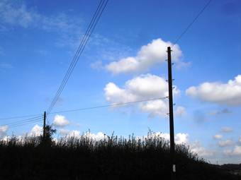

Fig 1, showing an example of cable having to pass under a similar height EL line

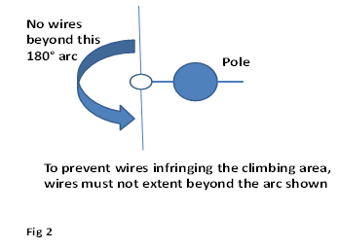

Fig 2, showing the 180° arc

1. any wires installed in this way must still meet the relevant ground carriageway clearance, as stipulated in EPT/ANS/A013

### Items required

|  |  |
| --- | --- |
| Item Code | Description |
| 026658 | Auger 16mm x 330 (SDS end) |
| 021240 | Ring Pole Head |
| 016286 | Steps Stand off |
| 016266 | Plugs creosote |
| 014700 | Screw Coach (for fitting steps) |
| 016988 | Telenco UPB |

1. Ensure all relevant guidance regarding changing steps is followed, and that you have all of the necessary equipment. If unsure of the task, refer back to your Control or Manager for assistance.

### Climbing the pole

Cables using this fixing method will be very rare, but if encountered, standard climbing practices to deal with an obstruction should be used to pass the cable. This entails use of the Work Positioning Belt temporarily to re-affix the Fall Arrest Lanyard above the obstruction. This is included in the relevant Climbing courses, and detailed in Health & Safety Handbook, SFY/HSH/D042.

## Dropwire Management

There are a number of activities that will always be undertaken during overhead provision or repair on the dropwire worked on. These are:

* Where a BT mounting block is fitted, the dropwire should be restrained by routing behind the mounting block and fixed with Straps Cable Fixing 12A pinned to the pole using the correct method.
* Where no mounting block exists, the Dropwire should be restrained at the pole top with straps cable fixing 12A pinned to pole, or Screws Spiral Eye using the correct method.
* The dropwire should enter BT correctly and be terminated using correct method for block / box connection.
* The spare pair in the Dropwire 10/10B should be formed correctly.
* When providing a new dropwire, any unused spare pairs should be left long enough to reach all terminations within the BT.
* Sleeves 2A should be correctly fitted to all ends of dropwire 10/10B/12 worked on or re-terminated.
* The correct dropwire clamp should be used, correctly fitted and secured to approved fittings and fixings.

## End User Lead-in (Provision & Repair)

The current acceptable lead-in’s, for new and replacement work are:

* Cable Down Lead (2 pair)
* Dropwire 10/10B
* Dropwire 11
* Dropwire 12 (where a larger conductor size is required)
* Dropwire 14 (CAD 55)
* Dropwire 15 (replacement for CAD55)

### Joints in the Lead-in

In exceptional circumstances a lead-in joint may be provided.

Examples where this is permissible are:

* Where the End User specifically requests the use of a coloured down lead.
* Where the lead-in is in excess of 200 metres.
* When it is necessary to place a joint in a lead-in, it will be made using the correct connectors which will be housed in an approved external Block Terminal 66B or Above Ground Closure.

### End user Premises

* End User lead-ins should be correctly routed and cleated neatly.
* Any new dropwire/lead-in entry to the End Users premises should be drilled through brick work, from inside at correct angle, unless End User permission refused.
* Dropwire entries should be sealed with an approved sealant.
* A drip loop must be provided at the entry point on external walls.
* Any newly provided NTE should be fitted vertically in a damp free position.
* Dropwire should be connected / terminated correctly in the NTE.

Key Tasks

There are a number of key tasks which must always be undertaken during the provision or repair of a Lead-in at the BT/ Above Ground Closure. They are:

* Where a BT is fitted to a mounting block, all dropwires and Lead-in’s should be, where possible restrained by routing behind the back plate and fixed with Straps Cable Fixing 12A pinned directly to the pole or wall.
* Where no mounting block exists, dropwires and Lead-in’s should be restrained with Straps Cable Fixing 12A pinned directly to the pole or wall.
* Lead-ins should be correctly routed behind mounting block of BT76, BT86 and Box Connection 18 (where fitted).
* Dropwire / Lead-in should enter the BT correctly and be terminated using correct method for block / box connection.
* All non-terminated pairs in the Lead-in should be formed correctly.
* Sleeves 2A should be correctly fitted to both ends of the Dropwire in BTs - they must not be fitted in AGC’s where the strength members should be crimped.

Replacement Policy

The following is applicable to Repair activities only:

* Where a fault has been cleared on the End Users overhead network to the quality standard as defined, and the Dropwire is not one which is of a current standard, the works executioner will contact the Control and ask for permission to replace the dropwire. If non Work Manager, the Control will record the dropwire replacement on the CSS fault report notes. If Work Manager the Engineer will record details on WM fault report notes.

## Current Standard Dropwire Fixings and Requirements

For all new and replacement work a maximum of one dropwire per fixing is allowed.

1. A single dropwire passing on and off the fixing is classed as 1 wire.

An End User fixing can be made with:

* Eyebolt Expanding 1A, fastened into brickwork, positioned 3 bricks down 2 in (See also 4.9.1).
* Eyebolt Expanding 2A / 2B fixed into a rendered wall (250mm below roof line and 250mm from wall edge or window).
* Bracket \*22 or Bracket \*\*32, into substantial timber.
* Bracket 44 and 51 fixed at least 250mm below roof line and at least 250mm in from edge/corner of wall/window/opening & secured using 2 Bolts Expanding 2A.

1. \*For exception. See: Non Road Crossing – uPVC Facia Spans without timber behind the uPVC.
2. \*\*In exceptional cases where extra height is required and no substantial timber exists a Bracket 32 fixed into separate bricks (using all 4 fixing points, with 2 studs expanding in diagonally opposite holes plus 2 zinc plated screws in the other 2 holes). Positioned correctly 3 bricks down 2 in.

* An existing End User dropwire fixing can be used providing it is one of the approved fixings detailed in this section, otherwise it must be replaced.

### Eyebolt Expanding 1A on Rendered/Harled Walls

The Standard fitting for Rendered / Harled walls is an Eyebolt Expanding 2A, however, it is permissible to use a 1A, subject to the following conditions.

* The Wire being provided / worked on does not cross any ROAD OR CARRIAGEWAY.
* The Span length does not exceed 40 metres.
* The Rendered / Harled surface does not exceed 13mm (1/2”) in depth.

1. See EPT/ANS/A013 for Road / Carriageway definitions.

### End User Dropwire Fixing in PVC Fascia

**Before any work on a property fitted with uPVC fascia (barge board) is carried out, permission from the owner must be obtained to drill the fascia and ascertain if the underlying structure is sound timber, or that the uPVC alone might be of sufficient thickness to support a fixing.**

**Identifying Sound Timber behind UPVC Fascia**

To confirm potential suitability for fixing purposes that there is substantial / sound timber behind an uPVC fascia, a small pilot hole (typically 18mm deep) should be drilled.

If after drilling the hole through the uPVC no timber is found, and the uPVC thickness is less than 20mm, the hole shall be filled with Sealant Silicone Clear (item code 127805). An alternative fixing solution will then be required.

**Bracket 22 or 32**

If, after drilling, sound timber is found, or the uPVC thickness is found to be 20mm or more, the Bracket may be fitted in line with the following:

* Silicone sealant shall be placed on the back of the Bracket, such that when screwed to the fascia, it oozes around the edge of the Bracket.
* Fixing shall be made using 3 Screw Steel Zinc Plated CSK Pozidrive 1½ x 12 item code 211467 (or longer if needed to enter fully the backing timber).

1. Sound timber is required behind all holes, where the uPVC thickness is less than 20mm

### uPVC Fascia where it is possible to identify the Rafter Ends

If no substantial /sound timber behind the uPVC fascia has been found, or the uPVC thickness is less than 20mm, but it is possible to identify the rafter ends, then a Bracket 22 may be fitted, using screws through the uPVC and into the rafter ends. It is recommended that the Bracket is fitted vertically.

* Fixing shall be made using either 2 ½” x 10 or 3”x10 wood screws, depending on the thickness of the uPVC.
* Silicone sealant shall be placed on the back of the Bracket 22 (as above).

**Non Road Crossing Wires**

Current fixing standards are designed to give a safety factor in the event of vehicle strike, which ensures that the dropwire will break before the fixing. However the only forces likely to act on non-road crossing wires are:

* The installation tension of the dropwire
* The weight of the dropwire
* The likely wind and ice loadings

In view of this, it is permitted to fix non road crossing wires, as detailed below:

**Non Road Crossing - uPVC Fascia Spans without Timber behind the uPVC or where uPVC thickness is less than 20mm.**

There is no industry standard for UPVC fascias, and they can be supplied in thicknesses varying from 5mm to 25mm.

* Prior to fixing, the thickness of the uPVC fascia should be identified.
* Brackets must not be fixed to fascias 6mm or less, unless it is fixed over the top of timber.
* Span lengths must be restricted to Maximum of 50m.
* Not to be used for road crossing spans.
* Fixing for the Bracket 22 shall be made using 3 Screw Steel Zinc Plated CSK Pozidrive 1 x 12 (item code 211458).
* Silicone sealant shall be placed on the back of the Bracket 22 (as above).

#### Dropwire fixings to metal clad buildings and BISF (British Iron & Steel Federation) metal clad houses.

Standards and Method of Installation

Bracket 22 is the only current fixing to be used for this method of installation

The Bracket 22 should be fitted on BISF house fascias as close to the corner as possible and on a suitable flat surface for clad buildings (see figures 2 & 3).

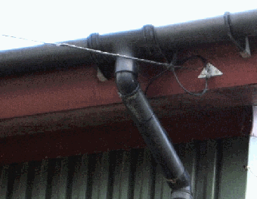

Figure 2 – Example of BISF house fascia

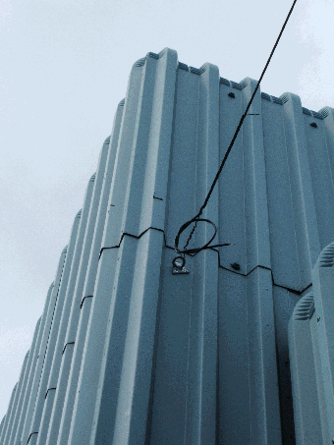

Figure 3 – Example of metal clad building

Check fixing point for signs of degradation i.e. rusting of fascia/metal clad panels, chosen fixing point not securely attached to building/cladding fixings missing or loose. If any of these are identified, DO NOT attempt to fix to the building / house.

If the identified fixing point is sound and meets the criteria then the following installation method is to be used observing all necessary health and safety requirements.

Position the Bracket 22 at the point where it is to be fitted & mark each fixing hole with Pen Marker Number 1 for marking the hole positions.

Using a Hammer Light Cordless or drill/driver use a 5mm metal drill bit to drill each of the 3 holes in the cladding/fascia.

Use of the Hammer Light aloft must be in accordance with SFY/HSH/D010

The Bracket 22 is then to be coated on the back with a thin layer of Sealant Silicone (Clear)

Fix Bracket 22 to Fascia/Cladding using 4.8 x 16mm multi grip pop rivets & a suitable rivet gun (see figure 4 & 5)

1. *This equipment is available via the I-Buy application in Gatekeeper from TW Engineering.*

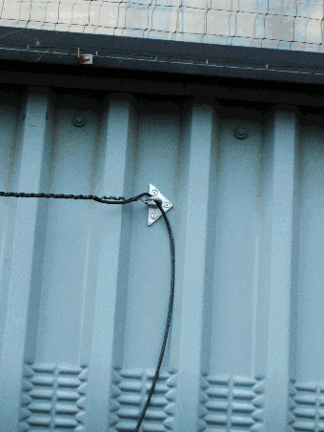

Figure 4 – Example of fixing to a metal clad building

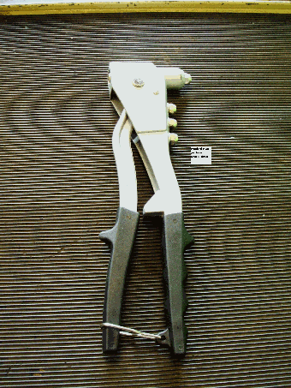

Figure 5 – Example of Pop Rivet gun

The rivets must be multi grip and conform to the ones shown in figures 6 & 7 as these compress equally around both sides of the fixing, ordinary plain rivets do not have this quality of fix.

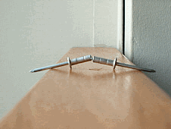

Figure 6 – Multi grip rivets

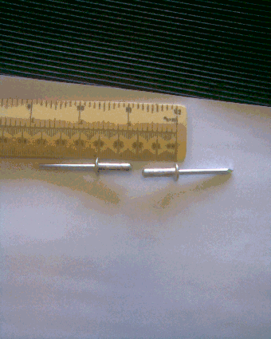

Figure 7 – 4.8 x 16mm Multi grip rivets

All current drop wires can be used including Fibre Drop Cable. Span lengths must not be exceeded as detailed in EPT/ANS/A011.

Attaching the drop wire to the building will be by Cleats 11B for rendered properties or Cleats self-adhesive 6B for properties where cleats 11B cannot be used.

For Risk Assessment.

1. It is advisable to wipe the surface before attaching cleats self-adhesive.

This method can still be used if the metal fascias on BISF houses have been overlaid with Plastic cladding, however 4.8 x 22mm multi grip rivets will be required (not shown in fig 7)

The use of ladder top & bottom end stability devices (including Microlite) are recommended when carrying out this procedure. Refer to SFY/HSH/D030 for safe use of ladders & access equipment by [clicking here](http://humanresources.intra.bt.com/index/safety-handbook/s5jspecific/15173)

This method of fixing may not be an everyday occurrence and there will be no need for every engineer to be equipped with this tooling, although demand in some areas will be higher, for example: Luton, Cardiff and High Wycombe and scope of equipment requirements will need to be assessed by local operational Managers.

1. *That this fixing method is only for Metal Clad and BISF type houses and not for applications where the standard method of Bracket 22 fitment can be used.*

Correct use and installation of Bracket 22 will be quality checked and audited under FPQ code 16216 i.e.:

Metal clad buildings and BISF (metal clad) houses

* Bracket 22 fixing used with correct rivets and silicone
* Fixed to sound flat surface

Pop Rivet guns and rivets are available via the iBuy site from:

T.W Engineering Ltd

Angular House

Eagle Road

Quarry Hill Industrial Estate

Ilkeston DE7 4RB

TW descriptions and part numbers are:

Multi grip rivets – 4.8 x 16mm rivets box 500 – TW 1771 £9.60 per box of 500

Multi grip rivets – 4.8 x 22 mm rivets box 500 – TW 1772 £16.50 per box of 500

Pop rivet gun – TW 1774 £22.60

Other tools and equipment required:

Drill Twist Metal 5mm Item Code 127021

Drill Electric Cordless Item Code 126851

or Hammer Light Cordless Item Code 039402 or similar

Bracket 22 Item Code 011114

Sealant Silicone (Clear) Item Code 127865

Pen Marker Number 1 Item Code 129408

Cleats Wiring Self Adhesive 6B White Item Code 072473

Cleats Wiring 11B Cream Item Code 073086

Cleats Wiring 11B Grey Item Code 073087

### Decision Chart

|  |  |  |  |
| --- | --- | --- | --- |
|  | Buildings with uPVC Fascia | Building has Standard Brick or Render Finish, or Suitable Timber. | Building is Metal clad type or BISF (British Iron & Steel Federation) Metal clad houses |
| ROAD CROSSING WIRES | It is permitted to fix a Bracket 22/32 If the plastic fascia is fixed over sound timber & fixed into rafter ends see 4.10.3 | Use standard fixing methods, i.e. Eyebolt 1A / 2A, or Brackets 22/32/44/51 | It is permitted to attach a Bracket 22 to these types of building providing details in Para. 4.10.3.1 are complied with. |
| ROAD CROSSING WIRES | It is permitted to fix a Bracket 22 only (not Bracket 32) IF it is fixed to the rafter ends (see 4.10.3 above) | Use standard fixing methods, i.e. Eyebolt 1A / 2A, or Brackets 22/32/44/51 |  |
| NON ROAD CROSSING WIRES | It is now permitted to fix Bracket 22 to plastic fascias using Screw Steel Zinc Plated CSK Pozidrive 1 x 12 item code 211458 providing details in Para. 4.10.2/3 are complied with. | Use standard fixing methods, i.e. Eyebolt 1A /2A , or Brackets 22/32 | It is permitted to attach a Bracket 22 to these types of building providing details in Para. 4.10.3.1 are complied with. |

Table 3: Decision Chart

SUMMARY OF FIXINGS TO uPVC FACIAS

* Check with and advise the End User how the wire will be installed, before work commences.
* Carry out an appropriate On site risk Assessment.
* Brackets 22 / 32 can be fixed to uPVC fascias, provided the instructions above are followed.
* It is NOT permitted to fix Brackets 44 or 51 to uPVC fascias.

### Connecting Dropwires to Porta cabins & Temporary Buildings

The direct attachment of Dropwire Clamps may be made to Porta cabins or other similar Temporary buildings subject to the following conditions.

* Short term structures only i.e. not expected to remain in place for more than 18 months.
* Structure has substantial stanchions or stacking legs, with lifting eyes or similar point to which Dropwire clamp may be attached.
* Material at proposed fixing point is of suitable thickness (Min 4mm / 3/16 inch).
* Minimum Dropwire ground clearances will be achieved.
* There are no other potential hazards. And the dropwire is clear of where people & equipment may pass.
* A full On Site Risk Assessment has been conducted.
* Where a Container Type Structure is encountered a fixing may be made using Ring Pole Head as shown in Figure 8



Figure 8: Container Type, showing fixing using half of a Ring Pole Head Dropwire

1. Both nuts supplied with the Ring must be used to form a “lock nut”.

* Cables should be strapped to the leg of the structure and enter the Cabin from underneath or through specified cable entry wherever possible. Drilling holes through exterior walls should only be used as a last resort.

### Definition of Faulty / Defective Fixings

A Faulty End User Dropwire fixing is any fixing that is not:

* An Eyebolt Expanding 1A fixed either into a single brick or fixed into a rendered/ harled wall where the dropwire does not cross over vehicular access.
* An Eyebolt Expanding 2A fixed into rendered wall.
* A Bracket 22 fixed into substantial timber.
* A Bracket 32 fixed into substantial timber or fixed into separate bricks (using all 4 fixing points, with 2 Studs Expanding 1A in diagonally opposite holes plus 2 zinc plated screws in the other 2 holes). Positioned correctly 3 bricks down 2 in.
* A Bracket 44 or 51 fixed at least 250mm below roof line and at least 250mm in from edge/corner of wall/window/opening & secured using 2 Bolt Expanding 2A or Eyebolt Expanding 2A

1. No dropwires are permitted to be attached to these Eyebolt 2As).

A Defective End User dropwire fixing is one which is:

* Fixed into the mortar or cement between the bricks (unless it is an Eyebolt Expanding 1A (as fitted above) or 2A fixed into render/harled wall).
* Fixed into rotting or decaying timber.
* Not securely fixed into the brickwork or substantial timber.
* Attached to a tree, shrub or lamp post.
* If dropwire needs to be replaced, renewed, re-erected or re-tensioned to the End users premises the End Users dropwire fixing should be inspected, and replaced if it is found to be faulty or defective.

### Pole Fixings / Attachments

For all new and replacement work approved pole fixings are:

* A Ring Pole Head Dropwire fixed correctly at the pole top.
* A Ring Pole Head Stand-off 1A fixed correctly into sound timber.
* A Bracket 22 fixed correctly into sound timber.
* A Hook Clamp Dropwire and Bolt 25 on a 15 way split ring head.
* An internal metal “C” Ring inside a Hollow Pole.
* Universal Pole Bracket (UPB).

1. Where a UPB is fitted to a DNO pole or a BT hollow pole, dropwires must not be fitted onto the UPB apertures.

## Current Standard Dropwire Clamps

Only current standard Dropwire clamps shall be used. These are:

* Clamps Dropwire 6A - For use on Hollow Pole.
* Clamps Dropwire 10A - Wood Poles & End User Premises.

1. 1. The clamp must be wrapped around the dropwire, not the wire around the clamp.
2. 2. See Glossary for further details on these products.

## Wire Clearances

All relevant clearances shall be maintained for the following:

* Carriageway - See EPT/ANS/A013 for details
* Power - See EPT/PPS/B023, B026, B037, B038 & B046
* Flying Wires - On Private Land, a Min distance of 3m above ground and 2m from Buildings is required. (This is a statutory requirement)

Where BT lines and power cables run parallel on and are cleated to walls, there shall be a minimum separation of 50 mm between the two sets of plant. Where it is necessary for the lines to cross, a bridging piece of durable non-conducting material should be used to ensure separation of 25 mm between them.

1. Power Cables are regarded as insulated and protected and therefore safe to touch.

A simple means of constructing a bridge is to use a short length of Protector Cable Abrasion (‘Tree-Guard’) wrapped onto the Openreach cable such that when cleated at each end of the PCA, it forms a bridge with the necessary 25mm clearance. Choose the size of PCA to match the cable diameter being installed.

1. In most instances, a piece of PCA 170mm long should form a bridge with cleats 140mm apart and give the 25mm clearance. See image below.

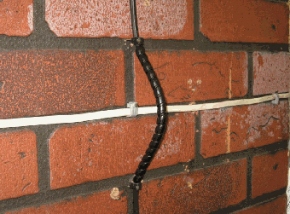

Use of PCA to form a bridge

## Span Length Limits

For all new / replaced Dropwires, the maximum dropwire span lengths must not be exceeded when the job is completed.

These are as follows:

* 68 metres when using an \*Eyebolt 1A, Eyebolt 2A or Bracket 22/44/51.
* 40 metres when using a Bracket 32.
* \*40 metres when an Eyebolt 1A is fitted to a rendered / harled wall and the Dropwire does not cross any Road / Carriageway. (See Section 4.9.1 for full details.)

1. Cable Drop Wiring No.15 can be used for spans up to 68 Metres including road crossings.

## Tree Pruning and Lopping

General

It may be necessary to prune or lop trees etc. to ensure that an aerial cable or dropwire will not sustain any damage during or immediately after erection.

* Before carrying out any work the Work Originator / Executioner shall ensure that all wayleaves or other permission has been obtained and that no preservation order preventing or limiting the pruning or lopping is in force.
* All pruning or lopping shall be accomplished in accordance with BS 3998.
* Upon completion of the work, the work executioner will be required to dispose of all cuttings not required by the tree owner and to leave the work site in a tidy condition. Special care should be taken to keep all cuttings from poisonous trees and shrubs away from cattle and livestock.
* The disposal of scrap materials shall be in accordance with BT's current environmental policy.

# Appendix 1 - Above Ground Closure

* The closure is not to be used to extend dropwires that are short into a DP block terminal, either pole or wall mounted.
* The use on Dropwire joints or damage repair in a mid-span situation is not allowed.
* It can be used on poles carrying a long dropwire route to provide dropwire joints and should be secured horizontally to the dropwire clamp using SCF 1 with the dropwires restrained to the pole using SCF12A pinned to the pole and should be utilised wherever possible.

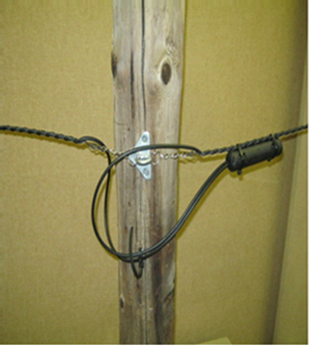

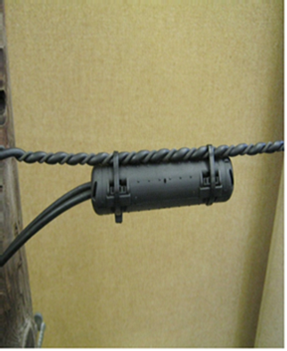

* At end user premises the closures are for use at the fixing position.

1. The 3 span & lead-in rule (section 4.6.8) will still apply to all scenarios.

* The above ground dropwire closure is also used to replace an existing BC16A and in some cases the BT66 for housing joints in dropwire only when it is entered as part of a repair or provision activity, including dropwire or lead in replacement or repair at the end users fix.
* The closure must be secured by cleating the cable to the building\* / structure\* at either end of the closure (figure 9). It should not be secured to the dropwire clamp at the end user premises.
* \*This can be carried out down to a height of not less than two metres above ground level when the end user fixing position is not accessible.
* Sleeves 2A must not be fitted in AGC’s, the strength members should be crimped
* Installation instructions are supplied with the closure.

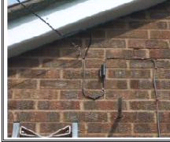

Figure 9

# Appendix 2 - Dropwires in Line of Route (DILOR)

## Dropwires in line of route

Where Dropwires are run together in line of route, they begin to act together and can apply a more significant, combined load onto Poles which left unchecked, may threaten the stability of a Pole. Because of this, we limit the number of wires running in line using the DILOR rule.

Previous DILOR rules assumed wires were loaded on Un-stayed Poles. However, the new rules detailed below, allow for more wires to be run in line, providing that Stays, or a counteringwire loadis present. See sections 3 and 4 below for full details.

## Un-Stayed Poles / Poles with no opposing wire load

Where multiple wires are running to an un-stayed Pole, or the Pole has no wires opposing that load, then the DILOR consideration applies. See illustration below.

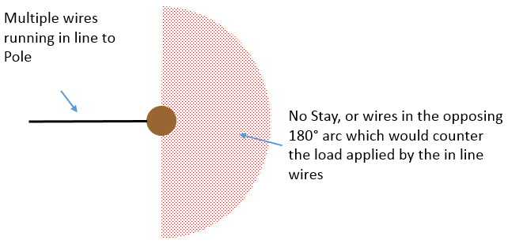

Figure 1 – Pole with no opposing load

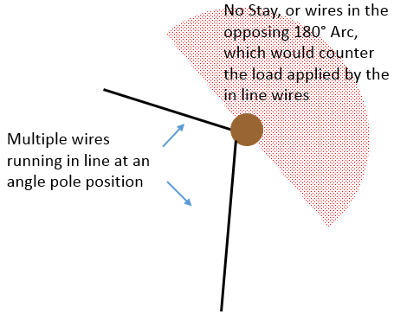

Figure 2 – Angle Pole with no opposing load

### Intermediate / in line Poles.

In general, In Line Pole poles need not be considered for DILOR, except where there is a deviation in the route. In such cases, DILOR should then be considered and illustrative indications of the maximum permitted angles before such consideration applies are shown below.

Where the angle is tighter than that shown by the blue lines i.e. For example, those shown in dotted red, then DILOR applies

**Trigger Angle for Light Class Poles:**

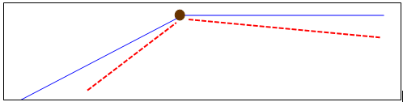

Figure 3 – Angle, Light Pole

**Trigger angle for Medium Class Poles:**

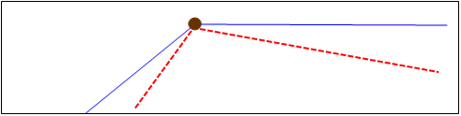

Figure 4 – Angle, Med Pole

### Loading limits

Where a pole has no Stay or wires in an opposing arc and it has been determined that DILOR applies, the maximum number of Dropwires permitted in line of route is shown in Table 1 (below).

1. These limits apply to Copper, Fibre wires, or a mixture of both types.

|  |  |  |  |  |  |  |
| --- | --- | --- | --- | --- | --- | --- |
|  | **Wires crossing carriageway** | | | **Wires not crossing carriageway** | | |
|  | One or both poles are Light class | Both Poles are Medium class | Both Poles are Stout Class | One or both poles are Light class | Both Poles are Medium class | Both Poles are Stout Class |
| Max permitted wires | 3 | 4 | 5 | 4 | 5 | 6 |

Table 1 – Maximum wires in line of route

**Note:**

These standards do not apply to poles classified SC, or any pole with a planting depth less than 1.2m, which is waiting an SC assessment –*The limit for these Poles is 2 wires.*

The rules also apply on Joint Use (JU) poles. NB: All JU poles will be a minimum of **MEDIUM** gauge.

The A1024 process *cannot be* used to report the provision of an additional wire in excess of the limit.

## Stayed Poles, or poles with an opposing wire load

The DILOR wire limits in Table 1 above assume that poles are un-stayed, or have no wires opposing the load applied by the in line wires.

Where Stays can be provided, or there are one or more wires present which oppose the in line wire load, a higher number of wires are permitted in line of route. See illustrations and Table 5 below.

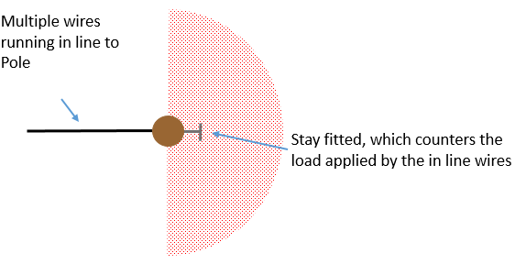

Figure 5 – Stayed Pole

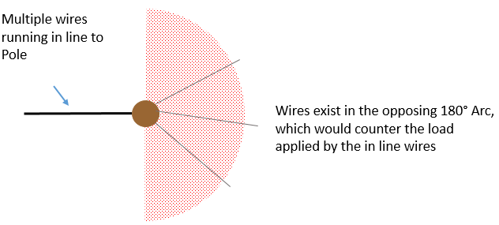

Figure 6 – Pole with opposing wires

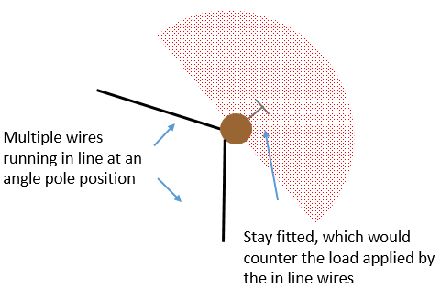

Figure 7 – Angle Pole stayed

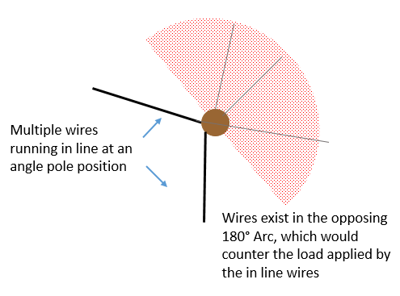

Figure 8 – Angle Pole with opposing wires

### Loading limits (Stayed Poles / Poles with opposing load

Where the Pole has a Stay fitted, or wires applying an opposing load, the following loading limits apply.

1. These limits apply to Copper, Fibre wires, or a mixture of both types.

|  |  |  |
| --- | --- | --- |
|  | Where one or both poles are Light Class | Where both Poles are Medium or Stout Class |
| Maximum wires | 8 | 12 |

Table 2 – Max wires - Stayed Poles / Poles with opposing load

## Options to mitigate DILOR problems

(a) Remove any redundant Copper Wires (particularly one’s you may make redundant by installing a Fibre / Copper Hybrid Drop)

(b) Rationalise any existing Copper wires that are beyond the DP using DW15.

The feed to a formally listed Copper DP (on network records) cannot be formed from a combination of Dropwires; it must be formed from either aerial cable (ASSC) or UG cable.

However, providing that a Box / Block are not formally recorded as a Distribution Point (DP). It is permitted to take multiple Dropwire 15’s into the central section of a Box Connection 18/19, and then break away radially with other Dropwires. This is the preferred alternative to using multiple BT66s.

When using Dropwire 15 as feed cables, a maximum of 5 x Dropwire 15’s for a BC18 and 2x Dropwire 15’s for a BC19 are permitted. If more than 2 feeds are required for a BC19, use a BC18 instead.

(c) Install an Aerial Cable to replace Dropwires

These standards are designed to offer flexibility, as well as matching the standards to pole capacity. However, where an aerial cable can be erected / installed, this should be the preferred solution.

(d) Fit Stays to counter the load applied by Dropwires (see 6.1.3 below).

## DILOR Q&A:

**Q:** What if there are Dropwires and Aerial Cables in line of route?

**A:** In these situations, the Poles should be Stayed

**Q:** Does the number of Stays required vary according to the number of Dropwires?

**A:** *No, single Stays are ok, regardless of the number of wires (within the limits shown in Table 2)*

**Q**: Is there a standard Base to Height (B:H) ratio required for the Stays?

**A:** *A Base / Height ratio of 1:2 is preferred. Where that can’t be provided due to limited ground space, the Vertical Stay Bracket can be deployed, which allows the anchor position to be located as little as 600mm from the Pole.*

END OF DOCUMENT